“留学助手”APP 的下载及学习信息的绑定
Download of "Study Abroad Assistant" App and Binding of Study Information

1、“留学助手”的下载及安装(Download and installation of "Study Abroad Assistant")
扫描二维码进行“留学助手”的下载及安装（如图1）
Scan the QR code to download and install "Study Abroad Assistant" (Figure 1)
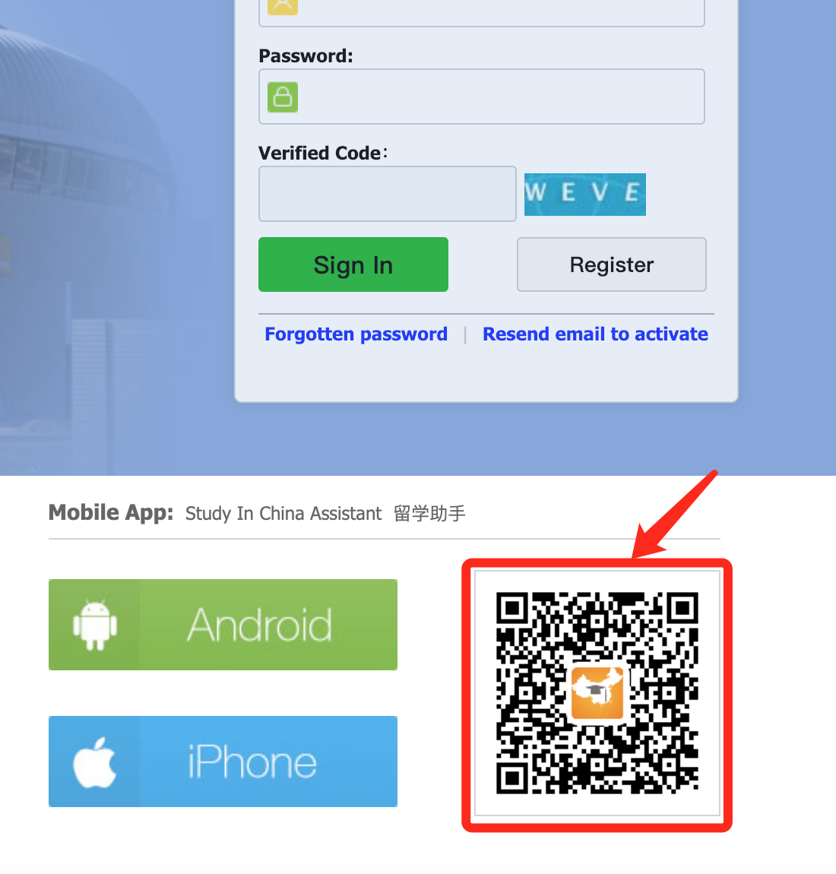

图1 (Figure 1)

2、进入“留学助手”（如图2）(Enter "Study Abroad Assistant" (Figure 2))
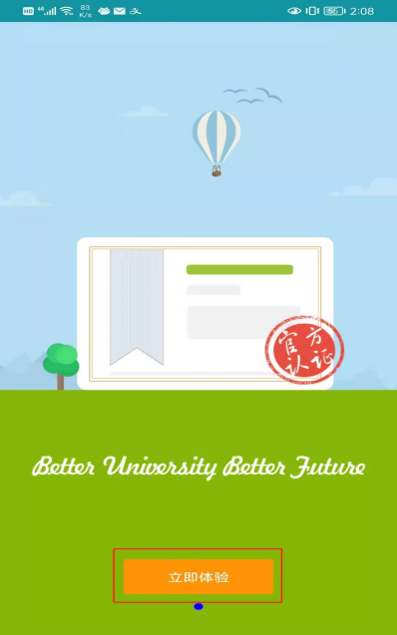
图2 (Figure 2)

进入账户登录页面(Enter the account login page)
以下两种方式任选一种登录。Choose either of methods to log in.

方法一：手动输入登录地址进入(Manually enter the login address)
输入我校前台学生端登录地址，进入账户登录页面。（如图3）
Input http://dmu.17gz.org to enter the account login page. (Figure 3)
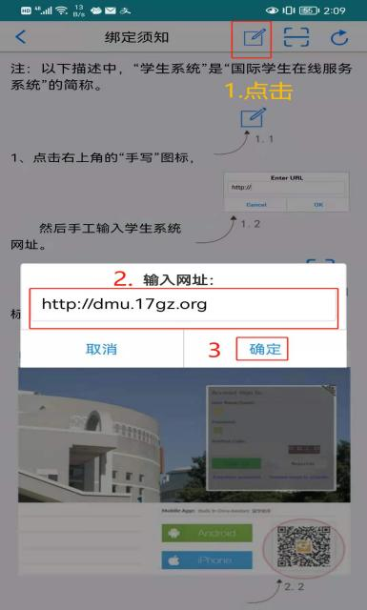
图3(Figure 3)

方法二：或者扫描二维码进入( Scan the QR code)
直接扫描学生登录界面二维码，进入账户登录页面。（如图4、5）
Scan the QR code of the student login interface directly to enter the account login page.(Figure 4, 5)
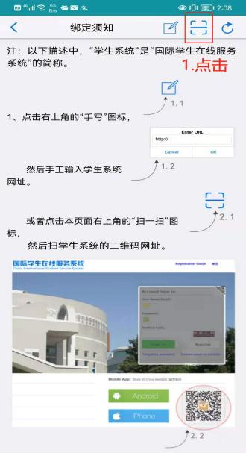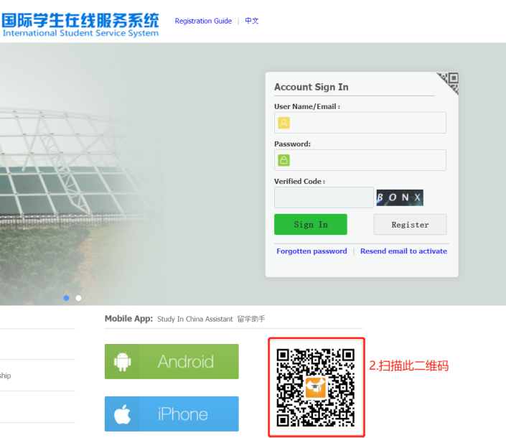
图5(Figure 5)
图4 (Figure 4)

4、登录账户(Login account)
输入网页版系统前台学生登录用户名和密码然后登录系统，进入学生信息绑定页面。（如图6）（如果无账号，可通过“注册用户”功能自行注册，详见附1；如果忘记密码或账号被锁定，可自行找回密码会解锁账户，详见附2）
Enter the login user name and password at the web version of the system and then log into the system to enter the student information binding page. (Figure 6) (If you don’t have an account, you can register yourself through the "Registered User" function, see Appendix 1 for details; if you forget your password or your account is locked, you can retrieve the password yourself to unlock the account, see Appendix 2 for details）
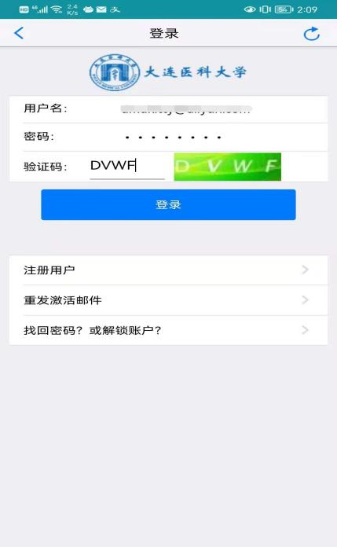
图6(Figure 6)

5、绑定学生信息(Binding student information)
登录成功后，请点击“添加绑定学生”（如图7），如果此账户有申请记录，则会显示“待绑学生列表”，点击学生信息后面的“添加绑定”，即可完成该学生信息的绑定（如图8）
After logging in successfully, please click "Add Bound Student" (Figure 7). If the account has an application record, the "List of Students To Be Bound" will be displayed. Click "Add Bound" behind the student information to complete this Binding of student information (Figure 8)
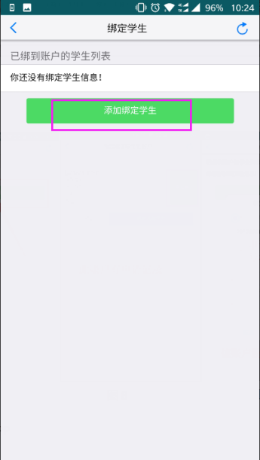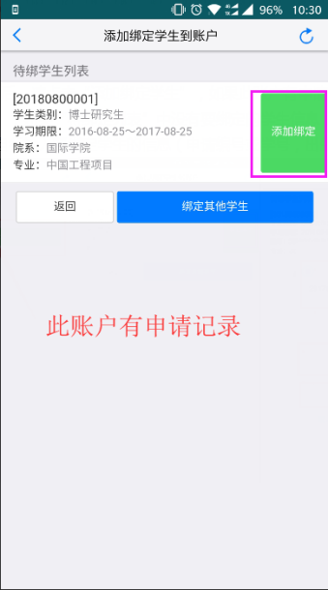
图8 (Figure 8)
图7(Figure 7)
如果没有申请记录，系统会直接让学生填写要绑定的学生信息（需填写“申请编号”或“学号”，“出生日期”和“国籍”）（如图9）；如果该账户之前已经通过网页版绑定过学习信息，则可以直接点击“绑定到手机APP”。（如图10）
If there is no application record, the system will directly ask the student to fill in the student information to be bound (the "application number" or "student ID", "date of birth" and "nationality" are required) (Figure 9); if the account has been previously bound through the web version, you can directly click "Bind to Mobile APP". (Figure 10)
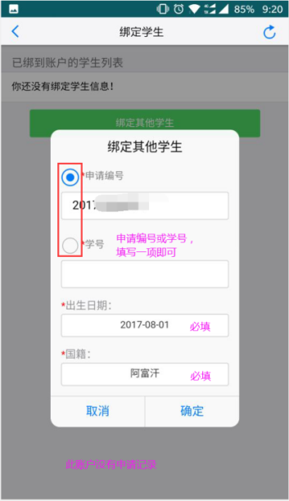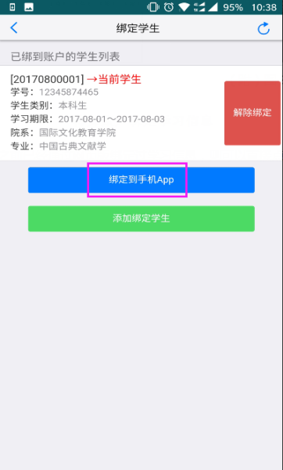
图10 (Figure 10)
图9(Figure 9)

6、绑定手机APP (Binding mobile app)
账户的学习信息绑定正确后，您点击“绑定到手机APP”（如图11），“留学助手”重启后，即可进入到应用界面（如图12）
After the study information of the account is bound correctly, click "Bind to Mobile APP" (Figure 11), and after the "Study Abroad Assistant" restarts, you can enter the application interface (Figure 12)
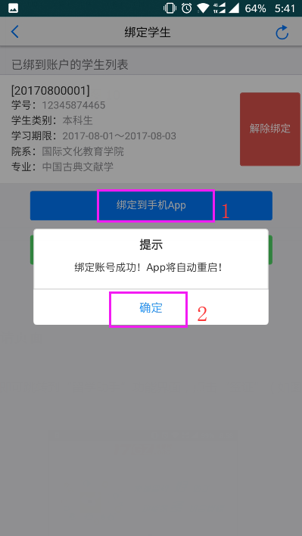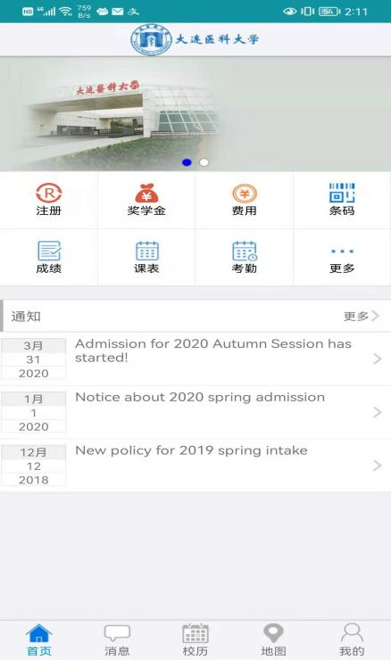
图12(Figure 12)

图11(Figure 11)

帮 助

附1 注册账户
如果没有登录账户，请点击“注册用户”（如 (附)图1），认真阅读“注册协议”后，点击“我同意”进入用户注册页面。（如 (附)图2）
If you do not have a login account, please click "Registered User" (as shown in (attached) Figure 1), read the "Registration Agreement" carefully, and click "I Agree" to enter the user registration page. (As (attached) Figure 2)
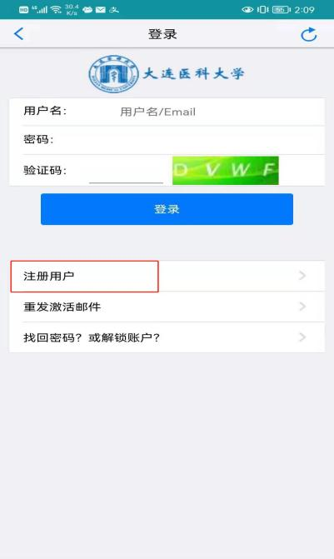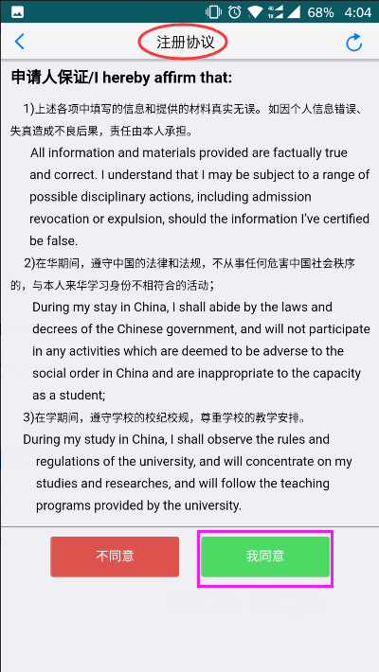
（附）图2 (attached) Figure 2
（附）图1 (attached) Figure 1

填写好用户注册信息后，点击“提交”（如 (附)图3），系统会提示您，用户是否注册成功。如果用户注册成功，系统会提示您自行登录邮箱激活用户（如 (附)图4）；如果用户注册未成功，系统会显示失败原因（如 (附)图5）。
After filling in the user registration information, click "Submit" (as shown in (attached) Figure 3), the system will prompt you whether the user registration is successful. If the user registration is successful, the system will prompt you to log in to the mailbox to activate the user (as shown in (attached) Figure 4); if the user registration is unsuccessful, the system will display the failure reason (as (attached) Figure 5).
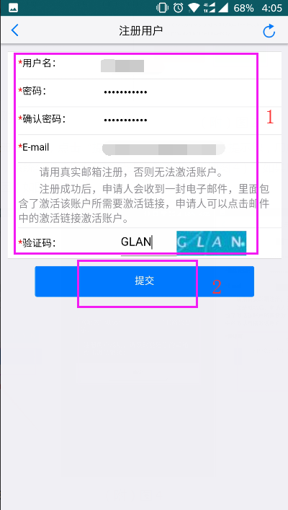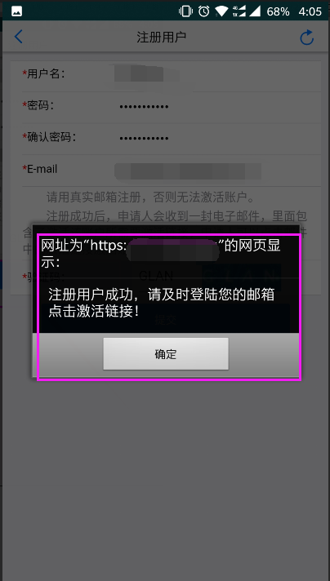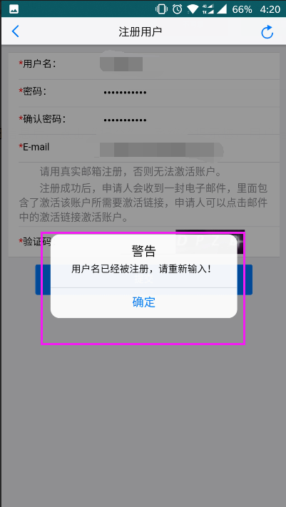
（附）图5 (attached) Figure 5

（附）图4 (attached) Figure 4
（附）图3 (attached) Figure 3

用户注册成功并登录邮箱激活账户（如 (附)图6）后，账户即可登录“留学助手”
( After the user has successfully registered and logged into the mailbox to activate the account (as shown in (attached) Figure 6), the account can be logged into the "Study Abroad Assistant")
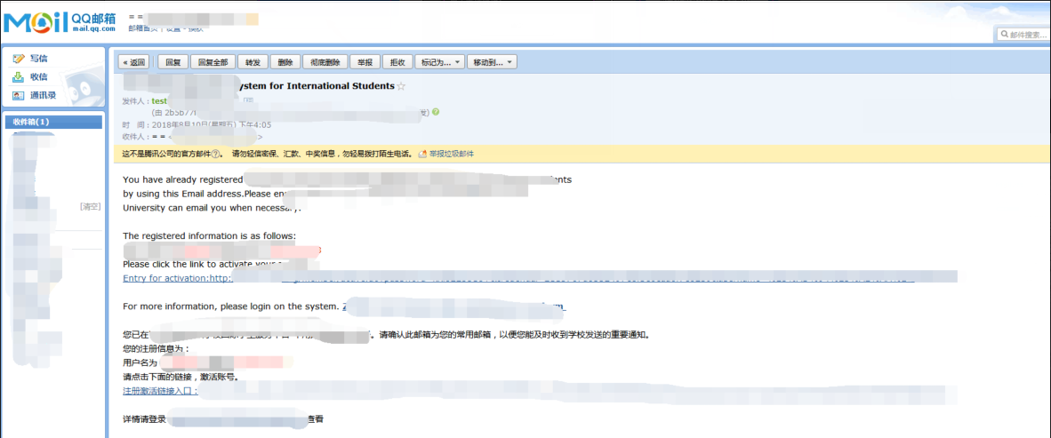

（附）图6 (attached) Figure 6

附2找回密码（或解锁账户）(Appendix 2 Password Retrieval (or account unlocking ))
如果您之前有账户，但是密码忘记了（或者登录时提示用户被锁定），可以点击“找回密码？或解锁账户？”进行账户密码的找回（解锁）操作（如 (附)图7）
If you have an account before, but the password is forgotten (or the user is prompted to be locked when logging in), you can click "Retrieve password? Or unlock account?" to retrieve (unlock) the account password (see (attached) Figure 7)
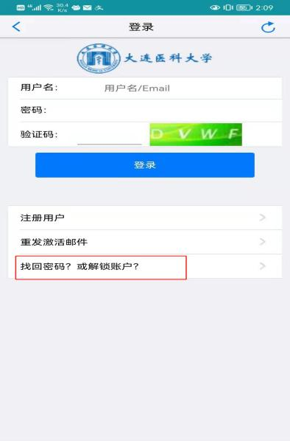
（附）图7 (attached) Figure 7)

输入用户名（或Email）和验证码，点击“提交”，即可将重置后的密码发送到账户注册时的邮箱中（如 (附)图8、9）
Enter the user name (or Email) and verification code, and click "Submit" to send the reset password to the mailbox when the account was registered (see (attached) Figure 8, 9)

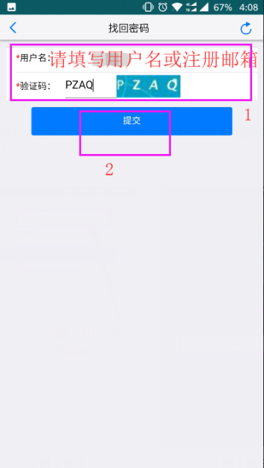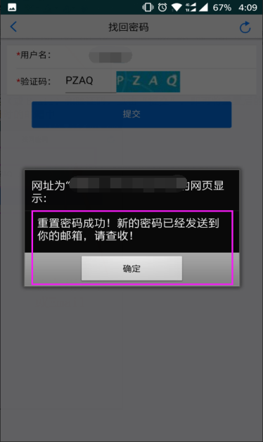
（附）图9 (attached) Figure 9
（附）图8 (attached) Figure 8

